Group Charter and Stakeholder Analysis
CSG2344 – Project Methods and Professionalism

Jordan Farrow (10653054)
Andrii Lukaschuk (10691443)
Aaron Kalaji (10670705)
Harrison Stubbs (10652268)
7 September, 2025
Table of Contents
1. Introduction 4
2. Project Charter 5
“Early Warning and Pothole Detection System in Western Australia” 5
2.1. Project Purpose 5
2.2. Background & Rationale 6
2.3. Partnership Structure 6
2.3.1. Western Australian Government 6
2.3.2. SSCI-Hooli 6
2.3.3. StereoLabs 7
2.3.4. Amazon Web Services 7
2.4. Governance Framework 7
2.5. Project Scope 7
2.5.1. In-scope 8
2.5.2. Out-of-Scope 9
2.6. Stakeholder Identification 9
2.6.1. Public Sector Partners 9
2.6.2. Private Sector Partners 10
2.6.3. Other Key Stakeholders 10
2.7. Project Objectives 11
2.8. Project Success Criteria 12
2.9. Funding & Resources 12
2.9.1. Budget Estimation 13
2.10. Risk Management 13
2.10.1. Delays & Supply Issues Impacting StereoLabs Supplying SSCI-Hooli With Hardware. 13
2.10.2. Citizen Concern Regarding Unconsented Camera Use. 13
2.10.2. Lack of citizen involvement of application 14
2.10.4. Failure to Follow ISO Standards During Application Development 14
2.10.5. Stakeholder Miscommunication 14
2.11. Legal & Regulatory Considerations 15
2.11.2. Compliance With Regulations & Standards 15
2.12. Project Timeline 17
2.13. Communication Plan 18
2.13.1. Internal Communication 18
2.13.2 External Communication 19
2.14. Reporting Requirements 19
2.15. Signatories & Approval 20
3. Team Contract 21
4. Diversity Matrix 24
4.1. Strengths and Opportunities 28
4.2. Weakness and Risks 28
5. CVs 29
5.1. Jordan Farrow CV 29
5.2. Andrii Lukashchuk CV 31
5.3. Harrison Stubbs CV 33
5.4 Aaron Kalaji 35
6. MS Project Usage 36
7. Stakeholder 37
7.1. Top three most influential stakeholders 37
7.1.1. Western Australian Government (Friendly Stakeholder) 37
7.1.2. StereoLabs (Friendly Stakeholder) 37
7.1.3. Department of Transport (Friendly Stakeholder) 37
7.2. Additional Stakeholder Considerations 38
7.2.1. J & M Asphalt (Hostile Stakeholder) 38
7.2.2. Local Councils (Both Friendly and Hostile Stakeholders) 38
7.2.3. Local Communities (Friendly Stakeholder) 38
7.2.4. Amazon Web Services (Friendly Stakeholder) 38
7.2.5. Main Roads Western Australia (Stakeholder) 38
8. HR and Technology Stack 39
8.1. Hardware 39
8.2. Software 39
8.3. Development team 40
9. Summary 41

1. Introduction
SSCI-Hooli are proposing a technology-driven solution for supporting the Western Australian Government in reducing road potholes. With $12 million in funding, SSCI-Hooli will deliver an early warning and pothole detection system that supports the ‘Future of Transport’ policy and vision.

SSCI-Hooli’s solution integrates stereo cameras connected to an embedded system which power a machine vision model across 1,690 public transport buses, creating a state-wide, real-time road monitoring network. The physical system will detect potholes with 90% accuracy and early road degradation with 85% accuracy. Alongside this will be a user-friendly application allowing citizens to report potholes directly. Known potholes will be displayed on a live web map which the Western Australian Government and its citizens will use to view pothole locations. For road degradation signs that may lead to potholes, a dashboard specific to the Western Australian Government is to be established. In addition to monitoring, the application enhances road user safety by notifying drivers of potholes within 800 metres of their location via smartphone integration.

By combining advanced computer vision, cloud-based analytics, and citizen reporting, this project reinforces the current reactive model the Western Australian Government uses for pothole reporting into a proactive model, making it more convenient and easier to report potholes before they increase in severity.

SSCI-Hooli has 5 months to create the deliverables and is responsible for the allocation of the $12 million budget. If predicted targets are met, the Western Australian Government will receive a technology solution which benefits road maintenance, whilst increasing citizen awareness of potholes and in turn, reduce vehicle related incidents.

2. Project Charter

“Early Warning and Pothole Detection System in Western Australia”

Public-Private Partnership (PPP) Project
Between Team Hooli & Western Australian Government

2.1. Project Purpose
This project is a partnership between the public partner Western Australian Government and private partner SSCI-Hooli. Provided with a $12 million budget, SSCI-Hooli is tasked with delivering the Western Australian Government a technology-driven solution for monitoring road conditions to detect potholes, in addition to early signs which lead to their formation through a user-friendly application. This system aims to perform this action automatically, whilst providing Western Australian citizens a more efficient reporting system. By doing so, all pothole related issues within Western Australia can be monitored with a single system, providing the government a way to maintain public road infrastructure and citizens a way to avoid vehicle related incidents.

This project aims to achieve the following (in-order of importance):

- Implement a stereo camera and embedded system into all Western Australian public transport buses within 2 months of project initiation.

- Automatically detect potholes on Western Australian roads used by public transport buses with an accuracy of 90% through a machine vision model.

- Automatically detect early signs of potential later potholes on Western Australian roads used by public transport buses with an accuracy of 85% through a machine vision model.

- Ensure machine vision model detects false positive potholes at a maximum rate of 5%.

- Ensure machine vision model detects false positive early signs with a maximum rate of 15%.

- Produce a web map within the developed application to display all detected and reported potholes.

- Implement a pothole reporting system for Western Australian Citizens within the application.

- Produce a statistic-focused dashboard for the Western Australian government to monitor early signs of pothole formations within the application.

- Establish a cloud server for application functionality and data storage.

- Notify users of the application within moving vehicles of potholes 800m ahead of its proximity.

2.2. Background & Rationale
During the winter season, Western Australia is severely affected by degrading road conditions caused by heavy rains and road usage. As a result, road potholes form which remain unactioned and increase in severity. In turn, this increases the risk of vehicle related incidents, negatively impacting citizen safety and vehicle conditions. Currently, the Western Australian Government utilises citizen report forms and live calls for identifying potholes. These methods are not only slow but also are unable to be occur while citizens are driving. As a result, citizens drive past potholes believing another individual will make the complaint, leading to no pothole identification. In the case a pothole is reported, it has likely become high in severity, requiring the Main Roads department or local councils to pay higher remediation costs.

The Western Australian Government will enter a partnership with SSCI-Hooli, providing $12 million in funding to produce a technology-driven solution for detecting potholes and early signs leading to their formation. By allowing SSCI-Hooli to carry out this project, Western Australian citizens will see a reduction in potholes, increasing road maintenance, satisfaction and safety through a technology driven-solution aligning with Western Australia’s ‘Future of Transport’ policy.

2.3. Partnership Structure

2.3.1. Western Australian Government
Main project partner providing $12 million in funding to SSCI-Hooli to produce a technology driven-solution for monitoring road potholes. The Australian Government contains the Department of Transport and Main Roads.

The Department of Transport has the role of providing SSCI-Hooli with all (1,690) public transport buses to be fitted with hardware for pothole and early sign detection, in addition to scheduling when these buses will be fitted with the physical system to maintain public transport operations. The department is also responsible for ensuring SSCI-Hooli complies with road policies. The Main Roads department will have the role of advising SSCI-Hooli on the accessibility of the application’s web map and early signs dashboard, ensuring it can be used effectively. This department’s involvement within the project is limited therefore, The Department of Transport and Western Australian Government itself will have higher responsibilities in ensuring the project is progressing as required.

2.3.2. SSCI-Hooli
Private partner with the role of providing the Western Australian government a technology-driven solution for detecting potholes and early signs. SSCI-Hooli has the responsibility of ensuring the project meets expected deadlines and deliverables, expected to occur through managing the technical stack of the project for application development and physical technology implementation. In addition, SSCI-Hooli will communicate with stakeholders of the project to ensure physical technology is delivered in respected timeframes, the application meets accessibility requirements and provide updates on project progress.

2.3.3. StereoLabs
StereoLabs is responsible for supplying SSCI-Hooli the stereo cameras and computing systems to be used for detecting potholes and its early signs through the machine vision model. StereoLabs are to ensure that the physical technology is delivered within the designated timeframe, allowing the project to succeed during its 5-month duration.

2.3.4. Amazon Web Services
Amazon Web Services is responsible for supplying SSCI-Hooli cloud-based server resources for storing pothole and early sign data, in addition to the application which the Western Australian Government and its citizens will use. It is their responsibility to ensure server up-keep remains consistent at all times and to communicate efficiently with SSCI-Hoolie to remediate related situations.

2.4. Governance Framework
All stakeholders will escalate matters of interest of the project to SSCI-Hooli. SSCI-Hooli will perform an internal review and if it is unable to be resolved or requires a higher consultation, the Western Australian government will be notified through the project steering committee. Decisions regarding changes to the project’s scope, and objective requirements will undergo reviews from the project steering committee before being finalised.

All changes to the project will be recorded by SSCI-Hooli to provide accountability and reporting to the Western Australian Government. To ensure communication remains clear, SSCI-Hooli will communicate weekly with the project steering committee and all other stakeholders on an as needed basis

2.5. Project Scope
This project will deliver the implementation of stereo cameras within existing Western Australian public transport buses for streaming road conditions to an application; this application will contain a machine vision model that detects existing potholes and their severity, in addition to early signs of potential potholes from the video feed. All buses will be equipped with embedded systems to run the machine vision model separately in real time, with detected road anomalies being sent for processing in the cloud application. This application will deliver a citizen focused aspect where potholes can be reported, in addition to alerting an active driver of potholes within proximity if a smartphone integrated car system (CarPlay, android auto) is in use. The application will include an interactive web map which displays all detected and reported potholes, in addition to its severity to be used by the Western Australian Government for remediation response and citizen awareness.

The project is to be fulfilled within 5 months, starting with the out-sourcing of cameras and initial design of the application. This will be followed by camera implementation within buses and development of the vision model and application. Finally, the vision model and application will be tested within select locations before a full release across Western Australia.

2.5.1. In-scope
The project will:

- Obtain hardware from external partners.

- Involve the production of a cloud-based application.

- Involve the production and training of the machine vision model.

- Involve detecting existing potholes though machine vision model.

- Involve detecting early signs of pothole formation through machine vision model.

- The machine vision model training data will be obtained through open source.

- Involve implementing hardware and applications within public transport buses.

- Involve the testing of a machine vision model and application

- Be applicable across Western Australia.

- Allow Western Australian citizens to report potholes.

- Notify Western Australian citizens utilising a smartphone integrated car system of potholes within proximity on a road through the application.

- Involve a web map showing known potholes through the application.

- Real-time video feed of road conditions to an embedded system, external to the cloud-based application.

- Send pothole and early sign data to a cloud-based application upon reaching a bus-port.

2.5.2. Out-of-Scope

- The project will not involve the marketing of the applications citizen aspect.

- The project will not involve the remediation of potholes or development of better patching solutions.

- The project will not involve creating physical technology, only the implementation of existing hardware.

- The project will not involve the relocating of public transport buses to SSCI-Hooli for hardware fitting.

- The technology solution will not be implemented in locations outside of Western Australia.

- The application will not require citizen or Western Australian Government employee personal data for interaction.

- Machine vision model training data will not be produced by SSCI-Hooli.

- The machine vision model will not detect road hazards outside of potholes and its early signs.

- The machine vision model will not detect walkway hazards.

2.6. Stakeholder Identification

2.6.1. Public Sector Partners

2.6.1.1. Western Australian Government - High Involvement
The Western Australian Government is a friendly stakeholder, providing SSCI-Hooli $12 million in funding to fulfil the project. Due to a high level of involvement, SSCI-Hooli is expected to communicate weekly regarding progress, alterations in the projects scope and possible issues which impact achieving project objectives through members in the Project Steering Committee.

2.6.1.2. Department of Transport Western Australia - High Involvement
The Department of Transport is a highly involved friendly stakeholder, expected to supply SSCI-Hooli with all 1,690 operational public transport buses to be fitted with the physical technology. Communication between the Department of Transport and SSCI-Hooli will occur throughout the implementation phase of the project to determine the number of buses undergoing changes at a single time. This will ensure that all buses are equipped with the necessary physical technology, whilst ensuring public transport functionality continues.

2.6.2. Private Sector Partners

2.6.2.1. StereoLabs – High Involvement
StereoLabs will supply stereo cameras and computer systems to be fitted within the public transport buses. As a result, StereoLabs has a high level of involvement within the project. Communications must occur between StereoLabs and SSCI-Hooli to ensure deliveries occur within expected timeframes, ensuring delays do not occur to the project’s development phase. Furthermore, SSCI-Hooli will utilise StereoLabs’ development toolkit for implementing camera functionalities, with the expectation that StereoLabs will provide support where required.

2.6.2.2. Amazon Web Services – Low Involvement
Amazon Web Services will supply two ‘EC2’ instances to store potholes and early warning data, in addition to powering the application. This contract will bind SSCI-Hooli to these instances for a year. After the project completion, the server lease will be provided to the Western Australian Government with monthly payments covered. Communication between Amazon Web Services and SSCI-Hooli is expected to be minimal, with communications only to occur upon server failures.

2.6.3. Other Key Stakeholders

2.6.3.1. Main Roads Western Australia - Medium Involvement
Friendly stakeholder Main Roads is involved in remediating potholes and unsatisfactory state-controlled road conditions, such as highways and freeways. This application will benefit the department, allowing for faster pothole detection, leading to faster action on road maintenance. Main roads will utilise the application to action known potholes therefore, communication with SSCI-Hooli is expected to occur during the planning and implementation phase of the application to ensure the application’s user-friendliness.

2.6.3.2. Local Councils – Minimal Involvement
Local councils are expected to be both friendly and hostile stakeholders. Local councils will benefit from the detection of early signs of pothole formations, leading to reduced road maintenance costs. However, as known potholes will be displayed on a map, the local council may feel added pressure from their community for lack of remediation attempts, causing the stakeholder to turn hostile. SSCI-Hooli will communicate with local councils on an as needed basis to obtain feedback on application accessibility.

2.6.3.3. Local Communities – Low Involvement
Local communities involve citizens of Western Australia within local council areas. They are expected to be friendly stakeholders due to the benefits of this app towards the public infrastructure they utilise. SSCI-Hooli is expected to communicate with various local communities on application accessibility and user-friendliness.

2.6.3.4. J & M Asphalt – Minimal involvement
Pothole repairers such as J & M Asphalt will be hostile stakeholders to this project, caused by a loss in income from the reduction of potholes. As the pothole and its severity increases, so does the cost repairers place on its remediation. Through detecting potholes early, severity remains low leading to a smaller price to repair. Companies may see an increase in repair costs for low severity potholes to maintain past incomes. Whilst SSCI-Hooli will not communicate directly with companies such as J & M Asphalt, it is recommended the Western Australian Government help maintain friendly relations with local councils.

2.7. Project Objectives

This project will achieve the following objectives:

- Implement a stereo camera and embedded system into all Western Australian public transport buses within 2 months of project initiation.

- Automatically detect potholes on Western Australian roads used by public transport buses with an accuracy of 90% through a machine vision model.

- Automatically detect early signs of potential later potholes on Western Australian roads used by public transport buses with an accuracy of 85% through a machine vision model.

- Ensure machine vision model detects false positive potholes at a maximum rate of 5%.

- Ensure machine vision model detects false positive early signs with a maximum rate of 15%.

- Produce a web map within the developed application to display all detected and reported potholes.

- Implement a pothole reporting system for Western Australian Citizens within the application.

- Produce a statistic-focused dashboard for the Western Australian government to monitor early signs of pothole formations within the application.

- Establish a cloud server for application functionality and data storage.

- Notify users of the application within moving vehicles of potholes 800m ahead of its proximity.

2.8. Project Success Criteria

The success of this project will be defined by achieving the following:

- All 1,690 Western Australian Public Transport buses are equipped with the physical hardware systems.

- Machine vision model detecting potholes with a 90% accuracy and maximum 5% false positive rate.

- Machine vision model detecting early signs with an 85% accuracy and maximum 15% false positive rate.

- Reducing response times to potholes remediation by 35% within 6 months of system deployment.

- Reducing vehicle related incidents involving potholes by 50% within 12 months of system deployment.

- Detected and consistently reported potholes are viewable within the web map no more than 3 hours after detection.

- Drivers are notified of potholes in an 800m proximity with a 100% success rate.

2.9. Funding & Resources
The Western Australian Government is to commit $12 million in funding for project development. It is to be allocated towards hardware procurement and installation, application development and operational costs of the systems. Upon project completion, the Western Australian Government will receive the completed technology solution, in addition to 7 months of cloud server lease. In-kind contributions will also be received, such as public transport buses, relevant road policy advice and application accessibility feedback. StereoLabs will contribute stereo cameras and embedded system goods to SSCI-Hooli at a reduced price to ensure project success. Amazon Web Services will provide two ‘EC2’ instance cloud servers for application functionality.

Contributor | Contribution
Western Australian Government  - Department of Transport  - Main Roads department | - $12,000,000 commitment funding  - 1,690 public transport buses  - Road regulation advice  - Application accessibility feedback
StereoLabs | - 1,692 Zed X stereo cameras  - 1,692 Zed Boxes  - Order discount
Amazon Web Services | - 2 ‘EC2’ cloud server instances

2.9.1. Budget Estimation

Cost Component | Estimated Cost (AUD)
Hardware Costs | 6,810,000
Stereo Cameras | $1,600,000.00
Embedded systems | $4,800,000.00
Cabling | 110,000.00
Shipping | $50,000
Hardware installation | 250,000
Development Costs | 1,850,000
Development systems | 300,000
Application Development | 1,500,000
Training | $50,000
Operational Costs | $1,040,000
AWS 'EC2' server instances | $10,000
Application maintenance (networking, patches, cyber security) | 1,200,000
Training stakeholders | 30,000
Bonuses | $850,000
Contingency Reserve | $1,450,000
Total | $12,000,000

2.10. Risk Management

2.10.1. Delays & Supply Issues Impacting StereoLabs Supplying SSCI-Hooli With Hardware.
Due to the project relying on physical hardware supplied only from StereoLabs, unexpected delays within its delivery are a major risk to project success. To mitigate this risk, hardware will be ordered and supplied within 4 weeks of project initiation, allowing for able time to deal with delays. In addition, SSCI-Hooli will communicate every two-days with partner StereoLabs to ensure delivery is on schedule. In the event of a delay occurring, StereoLabs is to notify SSCI-Hooli of the delay length and the new delivery date. SSCI-Hooli will assess the possibility of allowing the delay dependent on the current project timeline and determine if another partner is to be involved in supplying hardware.

2.10.2. Citizen Concern Regarding Unconsented Camera Use.
Unaware Western Australian citizens may share concerns of camera use believing recordings of individuals are occurring without consent. This misconception could spread, producing distrust and dissatisfaction in the Western Australian Government. Without citizen satisfaction, the application will not be used, resulting in pothole reporting not occurring. This will put the project at risk of being deemed a failure, with early signs occurring throughout project development creating a risk of cancellation. The Western Australian Government will need to mitigate this risk through advertisements, marketing that the cameras are not taking videos, instead scanning in real time for potholes and only recording pothole locations and severity.

2.10.2. Lack of citizen involvement of application
If citizens were unaware of the applications existence, potholes would remain undetected in areas which public transport buses do not travel, causing potholes and their negative impacts to remain. Furthermore, it could lead to the project being deemed a failure as it failed to detect potholes. To mitigate this, the Western Australian Government will need to create awareness through application advertisement, occurring within the last 2 months of the project's development time.

2.10.3. Data Security
Citizens and Western Australian Government data will not be stored within the cloud servers. Despite this, without satisfactory data security, detected pothole data is at risk of manipulation, insertion or deletion, reducing the effectiveness of the application. SSCI-Hooli is expected to follow ISO/IEC 27001, a recognised standard for securing information technology systems. Specifically, SSCI-Hooli must ensure stored data is encrypted and has policies in place for maintaining system security and incidence response.

2.10.4. Failure to Follow ISO Standards During Application Development
By failing to follow ISO standards, SSCI-Hooli is at risk of creating an unsafe and unreliable technology solution. Mitigation involves SSCI-Hooli acknowledging and abiding by the ISO standards noted in section 2.11.

2.10.5. Stakeholder Miscommunication
Miscommunication between SSCI-Hooli and its stakeholders will cause the project to be defined incorrectly, leading to the technology-solution being developed incorrectly. As a result, the Western Australian Government will not receive a technology-driven solution which achieves its assigned objectives and will not meet its success criteria's. Mitigating miscommunication is a joint-responsibility between all stakeholders and SSCI-Hooli, where all parties are encouraged to raise concerns during occurrences. This communication will occur weekly with the Project Steering Committee, in addition to other stakeholders on an as needed basis.

2.11. Legal & Regulatory Considerations

2.11.1. Project Steering Committee Members
- Andrii Lukashchuk (SSCI-Hooli Project Manager)
- Jordan Farrow (SSCI-Hooli Deputy Project Manager)
- Peter Woronzow (Director General, Department of Transport and Major Infrastructure)
- Phil Greenhalgh (Chief Information Officer, Business Information Systems DoT)
- Brian Leveson (Director, Legal and Legislative Services)

2.11.2. Compliance With Regulations & Standards

2.11.2.1. Western Australian PPP Guidelines
This project is a public private partnership between SSCI-Hooli and the Western Australian Government. As a result, SSCI-Hooli are to comply with the following frameworks to ensure project funding is valued, SSCI-Hooli are held accountable for project deliverables and handle all risks which come from innovating on public infrastructure.

2.11.2.2. Privacy Act 1988
This project will not collect citizen or government data thus, the Privacy Act 1988 will not be largely enforced within the project. Despite this, SSCI-Hooli will need to ensure citizen personal information is not collected when a pothole is reported and subsequently stored. If this were to occur, the Privacy Act 1988 would then need to be enforced.

2.11.2.3. Road Traffic Regulations 2014
State legislation SSCI-Hooli are to comply with to ensure the physical system (camera, embedded system) implementation within public transport buses does not breach established road laws and reduce human safety.

2.11.2.4. ISO 21448
Standard detailing safety considerations for vehicle embedded systems which have been implemented as designed which may still cause an impact to safety, in addition to system failures which may occur. The physical hardware embedded into each public transport bus may achieve its purpose of detecting potholes and its early signs successfully however, without reasonable understanding on its safety, it could cause hazards such as, fires, which will put harm to citizens in proximity and the applications success.

2.11.2.5. ISO/IEC 27001 & ISO/IEC27017
ISO/IEC 27001 is a standard for implementing and maintaining the digital security of a digital system. ISO/IEC 27017 is a standard for implementing and maintaining the digital security of cloud services. Citizen and government employee data will not be required to utilise the application. Despite this, the security of the application is to be considered as cyber attackers may obtain the ability to influence pothole data to produce false positives and remove recorded potholes and early signs. In doing so, potholes would remain unreported and the project would not have achieved its objectives.

2.11.2.6. ISO/IEC 25002
Standard for ensuring that the application SSCI-Hooli develops meet the defined scope requirements and achieve set objectives whilst achieving usability and accessibility.

2.11.2.7. ISO 16505
Standard detailing requirements for implementing cameras within vehicles to ensure performance and safety is achieved. Although this standard is intended for noting cameras replacing mirror usage, SSCI-Hooli is to consider the safety of implementing camera systems within public transport buses.

2.11.2.8. ISO/IEC 27033-1 & ISO/IEC 27033-2
Standards regarding the security of computer networks. By following these standards, pothole and early sign data sent through wireless connectivity remains secure and reliable.

2.11.2.9. ISO/IEC 23894
Discusses guidance on maintaining ethical standards within intelligent systems and risks of such systems. The proposed technology-driven solution will rely on a machine vision model for pothole and early sign detection therefore, ethics and risks of its deployment must be considered. Without its consideration, the application may achieve limited citizen engagement, limiting pothole reporting. In turn, this will reduce pothole monitoring and reduce achievability of project success criteria.

2.12. Project Timeline

Milestone | Duration | Start | End
Project Initiation and Setup
Contact stakeholders & committee for project alignment | 2 days | 1/1/2026 | 2/1/2026
Initial project compliance review | 3 days | 1/1/2026 | 5/1/2026
Procurement of hardware, software & cloud server lease | 18 days | 1/1/2026 | 26/1/2026
Hire project development team on contracts | 19 days | 1/1/2026 | 27/1/2026
Collect project data (pothole-600 dataset, bus scheduling) | 10 days | 5/1/2026 | 16/1/2026
Schedule hardware installations | 3 days | 18/1/2026 | 20/1/2026
Technology Solution Development – Phase 1
Install hardware & vision model application on 250 buses | 14 days | 2/2/2026 | 19/2/2026
System analysis of application | 13 days | 28/1/2026 | 13/2/2026
Develop initial application | 24 days | 16/2/2026 | 19/3/2026
Develop & train machine vision model | 15 days | 16/2/2026 | 6/3/2026
Machine vision model testing against success criteria | 4 days | 9/3/2026 | 12/3/2026
committee application demo & review | 1 day | 13/3/2026 | 13/3/2026
Technology Solution Development – Phase 2
Technology solution compliance review | 5 days | 16/3/2026 | 20/3/2026
Improve machine vision model for objective accuracies | 30 days | 16/03/2026 | 24/4/2026
Refine cloud infrastructure | 20 days | 16/3/2026 | 10/4/2026
Further develop current application | 20 days | 16/3/2026 | 10/4/2026
Develop early pothole sign dashboard | 20 days | 16/3/2026 | 10/4/2026
Obtain application accessibility feedback | 5 days | 13/4/2026 | 17/4/2026
Machine vision model testing against success criteria | 5 days | 27/4/2026 | 1/5/2026
Develop application (based on feedback) | 10 days | 20/4/2026 | 1/5/2026
Technology solution compliance audit | 4 days | 4/5/2026 | 7/5/2026
committee application demo | 1 day | 8/5/2026 | 8/5/2026
Deployment and Testing
Install hardware & vision model application on 1,440 buses | 51 days | 27/2/2026 | 8/5/2026
Application trialling with WA govt. & local councils | 5 days | 11/5/2026 | 15/5/2026
Application tuning to trial feedback | 7 days | 18/5/2026 | 26/5/2026
Handover (Project Completion)
Final application demo with committee | 1 day | 27/5/2026 | 31/5/2026
Project success evaluation with committee | 1 days | 27/5/2026 | 31/5/2026
WA govt. Employee application training | 4 days | 27/5/2026 | 31/5/2026
Application release | 4 days | 27/5/2026 | 31/5/2026
Handover of source code | 4 days | 27/5/2026 | 31/5/2026
Handover of documentation | 4 days | 27/5/2026 | 31/5/2026
Handover current leases | 4 days | 27/5/2026 | 31/5/2026

2.13. Communication Plan

2.13.1. Internal Communication
Contracted employees are to communicate within their assigned groups, with intergroup collaboration encouraged. Employees with queries / problems are to first consult with their group and relevant intermediary groups. Unsolved queries and problems are to then be forwarded to the deputy group manager (Jordan Farrow), then further to the project manager (Andrii Lukashchuk).

SSCI-Hooli will conduct weekly project meetings with the following development groups to assess progress is aligned with the project timeline:

- Application development team
- System analyst team
- Backend & cloud implementation team
- Physical system team
- Quality assurance team
- Digital security team

The deputy and main project manager are to attend these meetings fortnightly, with additional appearances on an as-needed basis. In addition, all employees are to attend a weekly brief at the beginning of each week to discuss weekly requirements and its relations to the project timeline and objective success.

Online communication within SSCI-Hooli is to occur through allocated MS Team channels.

2.13.2 External Communication
The Project Steering Committee is to meet weekly for discussions on the project’s current progress and capability in meeting the achieved objectives. The meeting will provide the Western Australian Government to raise concerns in the development of the technology driven solution or provide new requirements which the current timeline and scope must adapt to. It is to occur after internal SSCI-Hooli meetings to allowing involved stakeholders to be updated with present project information. Stakeholders not presented within the Steering Committee (in addition to committee members) are encouraged to request meetings on an as needed basis.

All stakeholders external to the steering committee will contact the deputy project manager Jordan Farrow on concerns such as but not limited to, physical supply issues and application accessibility concerns. These subjects will then be addressed in the following steering committee meetings if required or dealt with separately.

Public updates on project progress is to be handled by the Western Australian Government, with support and guidance from the Steering Committee meetings.

2.14. Reporting Requirements
Accompanying weekly Project Steering Committees will be a report produced by the project manager. The report contents are to include (but not limited to); new project requirements, possible issues and discussion points to follow up on in following committee meetings. Prior to each technical demonstration of the application with the Project Steering Committee, each development team will produce a report on current progress in relation to meeting the set objectives.

After the technology solution’s digital security has been evaluated, a report is to be produced to address vulnerabilities which may impact the projects implementation if exploited. Audits regarding the technology solution’s compliance to the specified regulations and policies in section 2.11 are to be enclosed within a report which can be relayed within Project Steering Committee meetings. Risks and issues which will cause project delay are to be reported to the Project Manager in writing, allowing complete transparency for the Project Steering Committee.

On a monthly basis, the current project spending is to be compared with the project budget and estimations to ensure overspending does not occur.

2.15. Signatories & Approval
Name | Signature | Date
Andrii Lukashchuk (Project Manager) | ______________________ | __________
Jordan Farrow (Deputy Project Manager) | ______________________ | __________
Peter Woronzow (Steering Committee member – WA government) | ______________________ | __________
Phil Greenhalgh (Steering Committee member – WA government) | ______________________ | __________
Brian Leveson (Steering Committee member – WA government) | ______________________ | __________

3. Team Contract

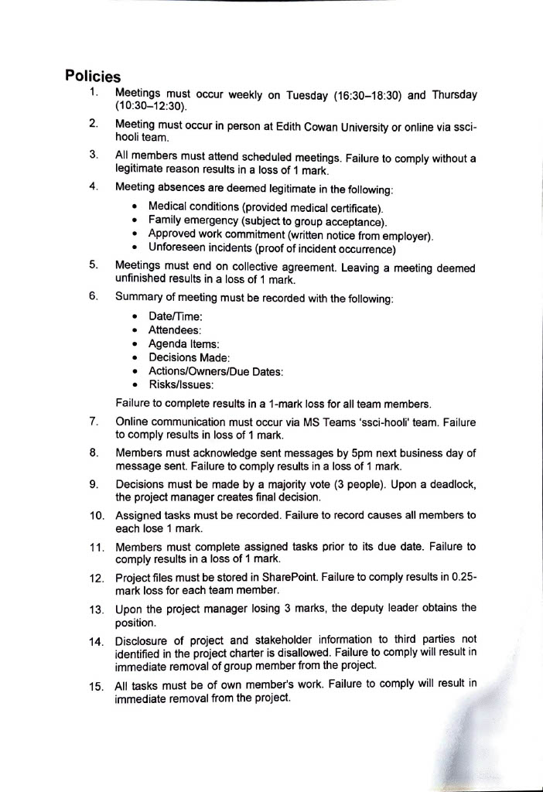



4. Diversity Matrix

Student Name | Cultural / Linguistic Background | Gender / Identity (Optional) | Primary Language(s) | Secondary Language(s) | Technical Skills (Programming, Networking, Cyber Security etc) | Preferred Learning Style (Visual, Auditory, Kinesthetic) | Soft skills (Communication, Leadership, Teamwork)
Aaron Kalaji | European | Male | English | Gaelic | Computer hardware and UI  Photoshop & the Adobe suite  Blender  Excel – full mastery of the XML structure | Wrote-learning  And repetition | Easy-going,  Fast typing ability  Good understanding of ICT concepts
Harrison Stubbs | British | Male | English | N/A | Programming (C++, Python);  Computer hardware;  OOP;  Excel spreadsheets;  System design;  Computer Networking | Visual and kinesthetic | Teamwork;  Collaboration;  Comfortable Presenting;  Critical Thinking;  Idea Pitching;  Responding to feedback
Jordan Farrow | Australian | Male | English | N/A | Programming (C++, Python, slight amounts of javascript);  Object Oriented Programming;  Data analysis;  Computer networking;  Packet Tracer;  Many things cyber security | Kinesthetic  (With a little Visual learning through diagrams) | Problem solving;  Lead by example;  Effective written/verbal communication;  Teamwork;  Critical thinking;  Organisation;  Initiative;  Adaptability;
Andrii Lukashchuk | European | Male | English | Ukranian | C#, C++, Python, .NET, SQL, Unity, Git, GitHub, MAUI, SQLite, NoSQL | Kinesthetic with Visuals | Experienced in presenting technical concepts clearly during project showcases and live presentations  Demonstrated leadership as team lead in the ICT Solutions Project  Good collaborator across multidisciplinary projects including VR game design, mobile app development, and robotics

Student Name | Certifications (CompTIA, CISCO, AWS etc) | Academic Strengths | Areas for Improvement | Technology Expertise levels & Major (1 = Beginner, 5 = Expert) | Hobbies/Personal Interests | Notes
Aaron Kalaji | NA | Memory and high-level mathematics  Engineering theory and circuit diagrams  3D modelling skills in Blender and AutoCAD  Matrix’s and high-level spreadsheets | C++ Programming ability is very limited without external tools  Understanding deeper concepts within networking  Wireframe diagrams  PK’s and FK’s | 3 (Software engineering) | Cars – 1980-2000 Hondas  Orthographic drawings of architecture  Modern politics | I'm all for keeping the boat afloat and doing my part to keep it that way.  I don't want to step on any toes but my bottom line is to get this done as quick as possible.
Harrison Stubbs | NA | Science  Mathematics  System design  Critical Thinking | Data structures and algorithms;  Java programming language;  AI understanding and development;  Linux ability; | 3 (Software engineering) | Basketball, Video-games, self-help and astrophysics
Jordan Farrow | NA | Mathematics (non-mental math)  Academic writing  Logical thinking  Critical thinking | Presenting (without splitting into clips or communicating effectively within it)  Programming ability in the languages I know  Network security  Linux effectiveness  Confidence in providing feedback (without feeling bad for it)  Mental math is horrible | 3 (Cyber security) | Bouldering  Reading  Video-games  Watching technology documentaries | I enjoy a project which challenges my thinking through both its requirements, but also the individuals which I am assigned with. I think that even if you are assigned a ‘challenging’ team, there are learning experiences and thus, positive insights to take out of it.  Although I am easy-going, I am an individual which can be very head strong if I believe my approaches are correct. Within this unit I hope to rely on others ideas and approaches more often.
Andrii Lukashchuk | NA | Software development  Simple full-stack applications  System planning and design  Team collaboration and leadership | Hard skills  Software skills  AI development  Linux commands | 3 (Software engineering) | Basketball  Gym  Movies  Reading  Hiking | I understand that in real-life projects leadership is an important factor, but I prefer to see it as coordination among all team members rather than a single person controlling others

4.1. Strengths and Opportunities
SSCI-Hooli consists of 3 software engineer majors, an advantage which will support discussions of the project's tech stack; this majority should provide opportunities for the tech stack to consist of smaller details, such as the different developer types and programming language frameworks which would normally be missed. Tech stack discussions will be further supported by all members experiences with low-level programming languages and techniques. Two members (Andrii, Harrison) also have strengths within public speaking, an effective skill which the group will take advantage of when presenting the project. Without these members, ideas may be communicated ineffectively and thus lose the project. The other two members (Jordan, Aaron) thrive within written environments, giving an opportunity for their ideas to be expressed through supporting presentation slides rather than through verbal communication. This balance gives the perfect opportunity for all members to have a part within assignment 2, due to it being split into a research-based task and verbal communication task. Finally, the diverse cultural backgrounds of each member will be a learning opportunity for all members. Finally, with all members being kinaesthetic learners, it simplifies the process of explaining ideas; all members can learn a concept by reading it off the document page, therefore, will not need to spend time ensuring other learning methods are achieved.

4.2. Weakness and Risks
All members state a level 3 in technology expertise. Due to this, it is still possible for the tech stack to lack depth as software engineering students are only beginning to learn about application development. There is a risk of budget estimations being far below what they would be because of this and therefore, will need close attention by all team members. Although all members offer diverse technical and soft skills, the limits in diverse cultural backgrounds to European and Australian will most likely cause similar perspectives between members and therefore, a limit in creativity. This will be a risk to the project as creativity will be essential in how we design our technology-driven solution which may lead to excess spending or a shallow budget estimation. Finally, with members having skills in certain areas, such as Jordan having noted skills in written communication, project progress may stagnate in this area if the individual fell ill. This is a massive risk towards meeting project deadlines if individuals are uncomfortable in temporarily taking the role. It can also lead to a decline in project quality since individuals must take up their less advantageous skills, in addition to balancing the load of their original tasks and those added on.

5. CVs

5.1. Jordan Farrow CV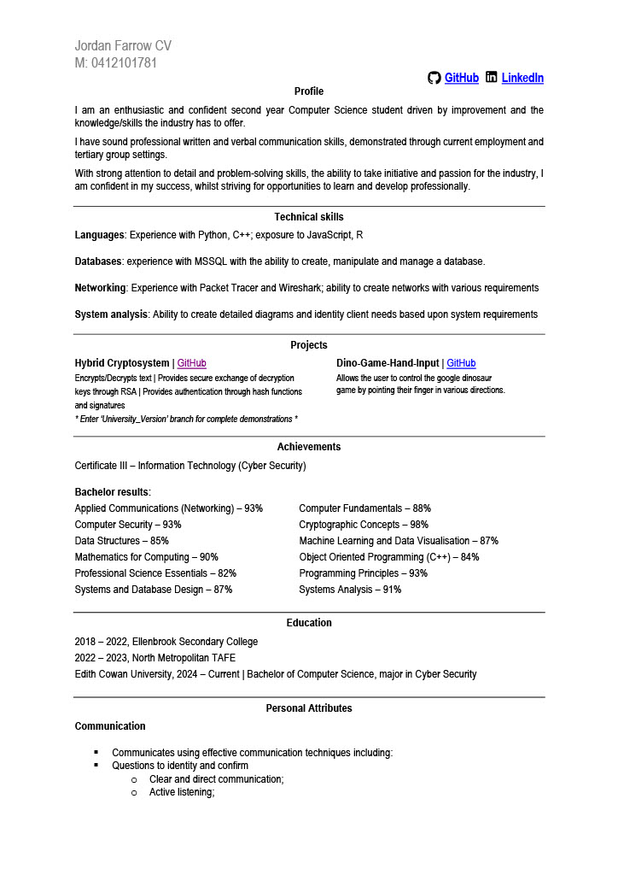
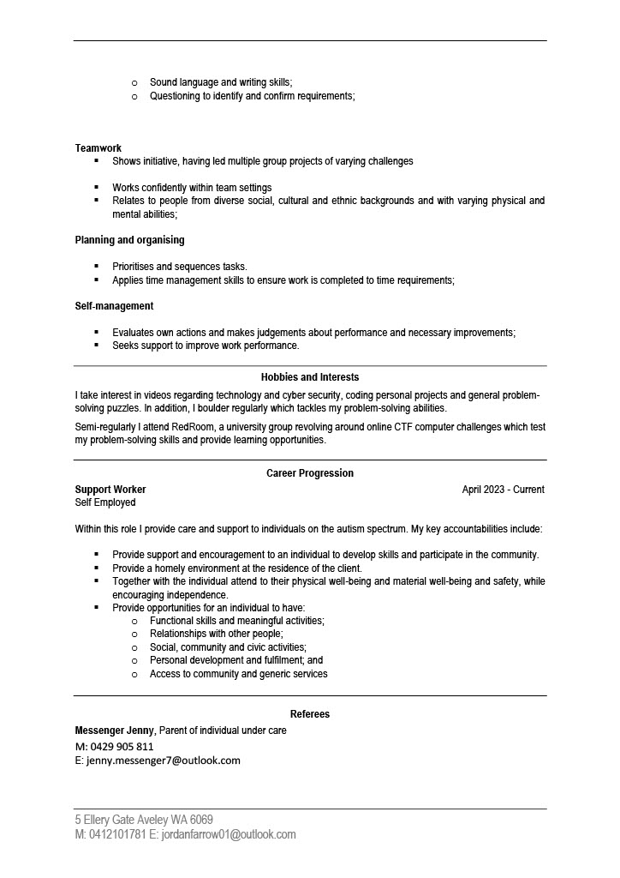

5.2. Andrii Lukashchuk CV

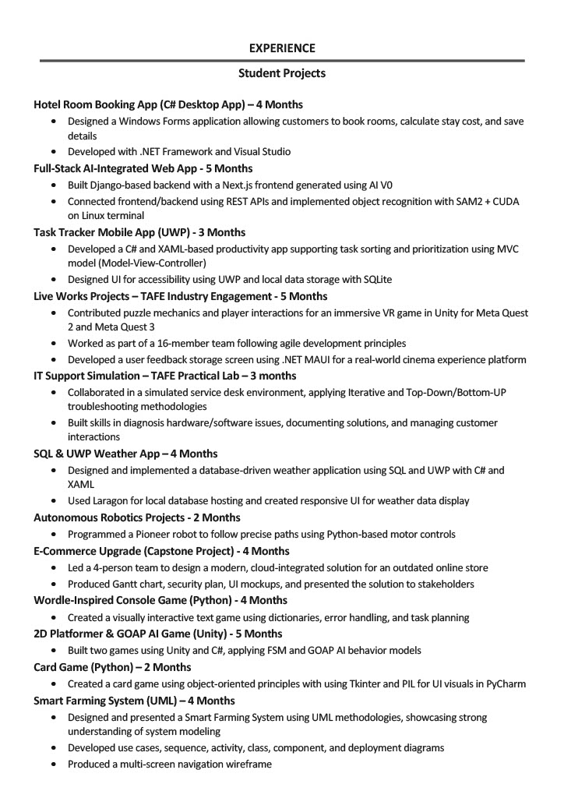

5.3. Harrison Stubbs CV
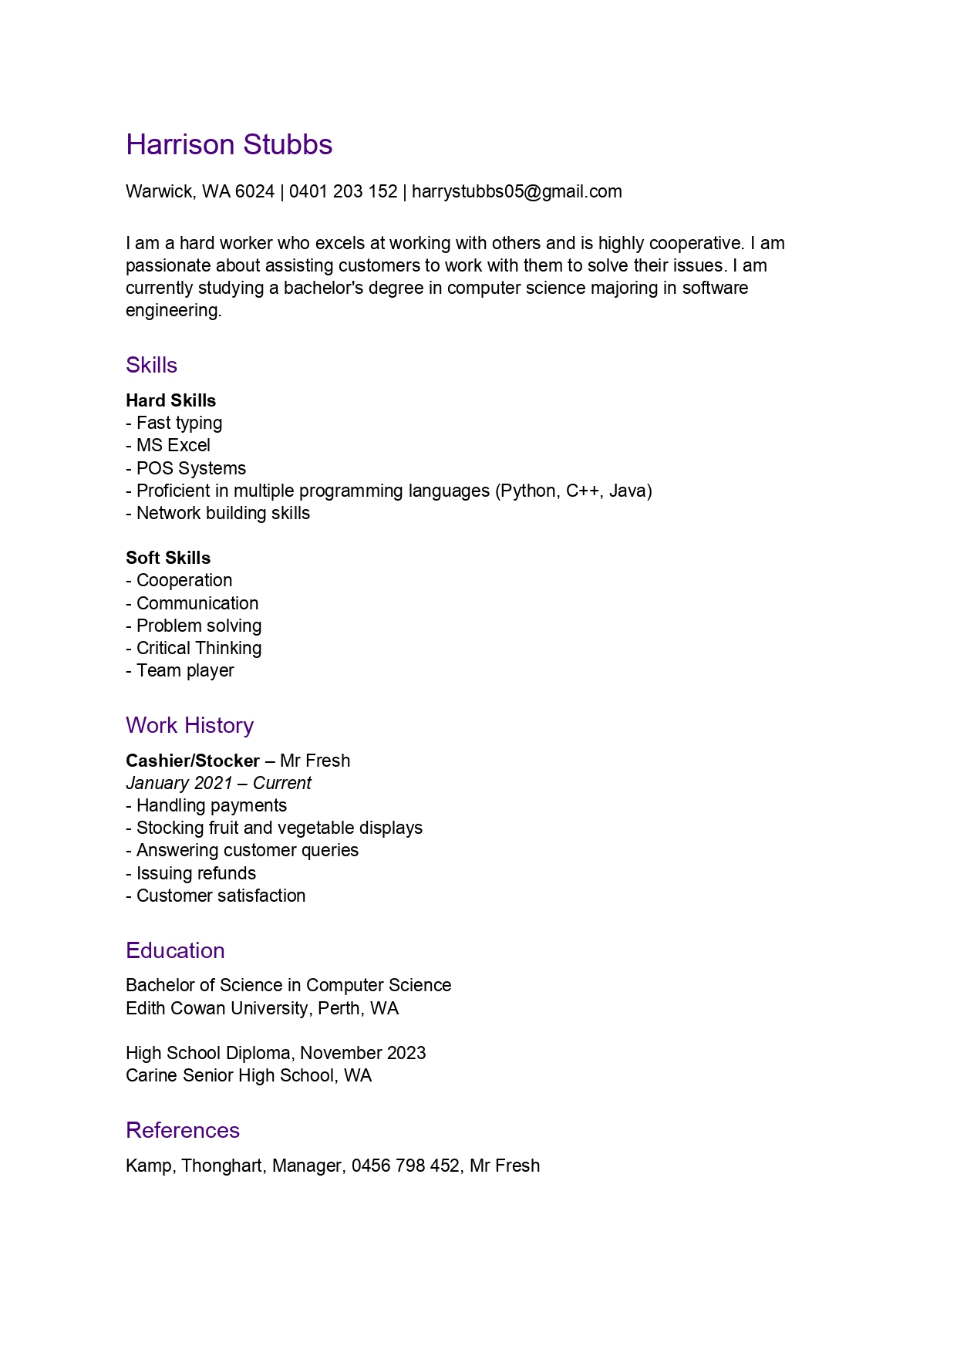


5.4 Aaron Kalaji


MS Project Usage
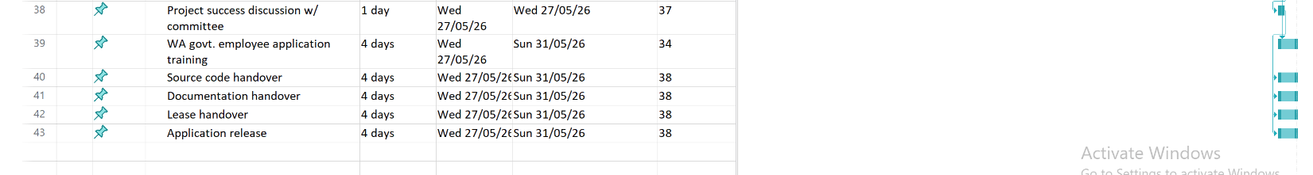
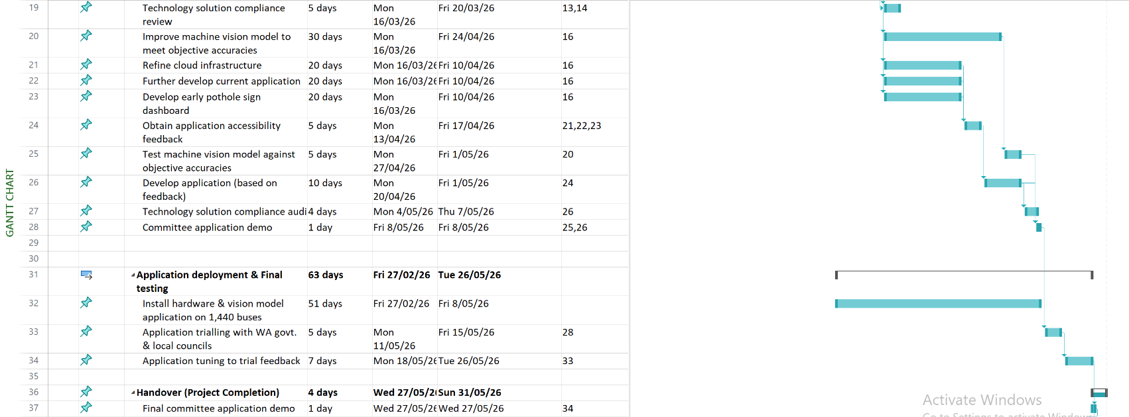
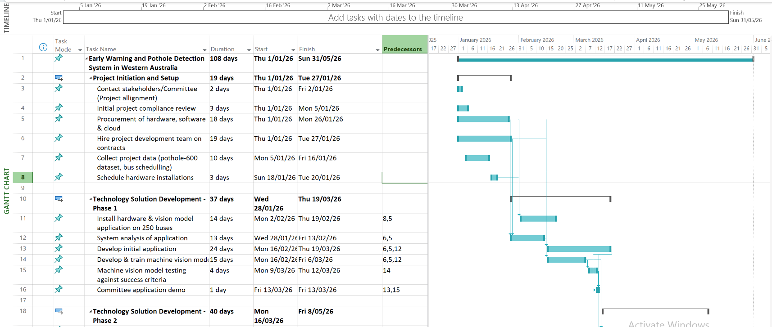

7. Stakeholder Analysis

7.1. Top three most influential stakeholders

7.1.1. Western Australian Government (Friendly Stakeholder)
The Western Australian Government is the most influential stakeholder of this project, being the public partner within the public-private-partnership (PPP) backing the project with $12 million in funding. Without the Western Australian Government, this project would not be occurring since they are the public partners which sought out private sectors to develop pothole detection technology. As a result, the Western Australian Government is highly involved in the development of the technology-driven solution that will be implemented across Western Australia. They are to communicate their requirements efficiently to SSCI-Hooli and raise concerns when these are not met. Failure to do so will result in the wrong technology being developed funding being wasted. This level of inclusion is to be achieved by allowing three Western Australian Government personnel to be included in the Project Steering Committee alongside the project manager and deputy project manager. Committee meetings are to occur weekly therefore, the Western Australian Government will have the ability to observe project progress, current and/or future possible issues and provide new requirements or clarity on prior requirements.

7.1.2. StereoLabs (Friendly Stakeholder)
StereoLabs is the second-most influential stakeholder, having the role of supplying the Stereo cameras and computer systems which are to be embedded in each public transport bus. This hardware is crucial to the success of this project, with the embedded systems executing the machine vision model, in addition to supplying it with real-time data of road conditions seen through the stereo cameras. StereoLabs will also provide a software development kit (ZED SDK) for utilising their cameras for machine vision models. Throughout this project, StereoLabs will be highly involved, communicating regularly to ensure the hardware will be supplied during the allocated timeframe (1/1/2026 - 26/1/2026). StereoLabs will also provide support for the machine vision model development team in effectively utilising the SDK in producing live data feeds on road conditions.

7.1.3. Department of Transport (Friendly Stakeholder)
Although the Department of Transport is contained within the Western Australian Government, it is being considered a separate friendly stakeholder. The Department of Transport will have a high level of involvement within the project, with the ability to schedule public transport schedules efficiently, allowing buses to become inoperable whilst technology fittings occur. Without close communication with this stakeholder, SSCI-Hooli would struggle to fit all 1,690 buses with the physical technology solution. Furthermore, this stakeholder can advise SSC-Hooli on possible road regulations which may impact project success or are being violated.

7.2. Additional Stakeholder Considerations

7.2.1. J & M Asphalt (Hostile Stakeholder)
J & M Asphalt will be a hostile stakeholder within this project, relying on pothole remediations for business. As potholes increase in size, J & M Asphalt (in addition to other pothole remediation businesses) would see an increase in payment to remediate it. By detecting potholes before they continue to increase in size, this stakeholder will be contracted to fix smaller potholes, resulting in smaller payments from local councils. There is also the possibility that business decreases, as pothole early signs are detected and remediated before J & M Asphalt is required. This stakeholder may consider raising their prices for remediating small potholes, incurring large costs on local councils. In turn, local councils may become hostile towards the project. These businesses will not have involvement within the project.

7.2.2. Local Councils (Both Friendly and Hostile Stakeholders)
Local councils utilise businesses such as, J & M Asphalt for pothole remediation. By detecting potholes at lower severities, the local councils will pay less on remediating potholes, allowing funding to go elsewhere within the community. Despite this, they can also be hostile stakeholders. As known potholes are placed on a publicly accessible web map, local councils may feel pressured by its community to act, spending money earlier or more than what was anticipated. Local councils will have minimal project interaction, occurring on an as-needed basis for application accessibility feedback.

7.2.3. Local Communities (Friendly Stakeholder)
Local communities are citizens of Western Australia within local councils. Citizens will be utilising the application for viewing and reporting potholes, therefore, will be involved in ensuring the application’s accessibility. This communication will happen with low project involvement near the end of development.

7.2.4. Amazon Web Services (Friendly Stakeholder)
Amazon Web Services will supply SSCI-Hooli with two ‘EC2’ cloud server instances, capable of storing both the application and pothole/early sign data. SSCI-Hooli is contracting cloud engineers therefore, communication with the stakeholder is expected to occur for ensuring server functionality.

7.2.5. Main Roads Western Australia (Stakeholder)
Friendly stakeholder Main Roads is involved in remediating potholes and unsatisfactory state-controlled road conditions, such as highways and freeways. This application will benefit the department, allowing for faster pothole detection, leading to faster action on road maintenance on crucial public roadways. By remediating early signs, costs can be reduced in the long-term. Main roads will utilise the application to action known potholes therefore, communication with SSCI-Hooli is expected to occur during the planning and implementation phase of the application to ensure it remains operation whilst user-friendly.

8. HR and Technology Stack

8.1. Hardware
To power the machine vision model, the Zed Box from StereoLabs will be used. Paired with it is the Zed X stereo camera produced by the same company, chosen for its high-quality camera and ability to measure depth (a feature which will be used for measuring pothole severity). By choosing the hardware from the same company, SSCI-Hooli is less likely to run into issues during hardware fitting and machine vision model development. For application development, contracted employees will receive ‘Maven 3D Developer’ Desktop systems with more than required computational power (these will be purchased, rather than leased). By going beyond what is needed, it means upgrades to developer machines will not need to occur at later dates.

The selectable hardware specifications for the hardware to be implemented within buses can be seen below:

ZED X Stereo Camera
- Polarizer filter
- 2.2mm lens
ZED Box
- Orin NX 16GB
- Built-in GPS

8.2. Software
To create the machine vision pothole detection model, the YOLOv5 learning model will be used and trained on the pothole-600 dataset. It will be implemented through the PyTorch library within the Python programming language. The use of Python is further supported by StereoLabs having a software development kit for their stereo cameras (which SSCI-Hooli is implementing), allowing efficient real-time video feeds.

Python will also be utilized in creating the cloud application for viewing potholes in a web map, reporting potholes and a dashboard for early sign statistics. With only Python this is challenging therefore, the Kivy framework will be used for creating the applications. An advantage of Kivy over other frameworks is its cross-platform capability, allowing accessibility to the application in Apple and Android devices.

To track and store application development, GitHub repositories will be utilised, with application development occurring within Visual Studio Code environments.

The above softwares are free to utilise therefore, do not incur additional costs upon SSCI-Hooli.

For communication, MS Teams will be heavily implemented, with each development team receiving a channel.

Although not inherently a software, SSCI-Hooli will be leasing two ‘EC2’ cloud services for Amazon Web Services to power the application and store the detect pothole and early sign data.

8.3. Development team
Our project requires a diverse team of specialists to ensure the successful deployment, operation, and long-term sustainability of the pothole detection system. The following roles and responsibilities illustrate how the technology stack is supported from hardware installation to system oversight.
The field technicians and installers are responsible for deploying and maintaining the camera hardware on public buses. Their work ensures that the vehicle-mounted cameras are correctly installed, calibrated, and remain operational. Supporting this hardware, embedded systems engineers configure the Jetson on-board computers, connect the cameras, and ensure that the detection software runs smoothly on the buses.
At the core of the project, machine learning and computer vision engineers develop and refine the YOLOv5 model for pothole detection, depth estimation, and privacy-preserving image processing such as license plate and face blurring. Their efforts are supported by a dedicated data annotation team, who use tools such as Label Studio and CVAT to manually tag potholes in road imagery, creating high-quality datasets for model training.
The cloud infrastructure is managed by backend developers and DevOps engineers, who design and maintain scalable databases, GIS dashboards, and servers that allow real-time data access. Complementing this, mobile application developers (both frontend and backend) are tasked with creating a user-friendly app that allows citizens to view and report road conditions directly from their devices.
To ensure integration with government processes, system integrators and software engineers connect the AI-powered detection outputs with existing work-order and road maintenance systems. This allows pothole detection events to be seamlessly converted into actionable repair requests. Meanwhile, cybersecurity specialists safeguard all data collected by ensuring compliance with WA Government regulations, protecting sensitive information, and maintaining strong privacy measures.
Operational continuity is supported by MLOps engineers, who monitor deployed AI models, retrain them with new data, and roll out performance improvements over time. Overseeing the entire initiative, project managers and business analysts provide strategic coordination, ensuring that timelines, budgets, and deliverables are met, while aligning technical progress with government and community needs.
Together, this multidisciplinary team and technology stack ensure the project’s success, balancing innovation, technical rigor, and compliance with public-sector requirements.

9. Summary
This project brings together multiple technological, organizational, and human resource components into a unified system designed to improve road maintenance efficiency across Western Australia. The integration process has been guided by three principles: interoperability, scalability, and compliance.
At the technical level, integration connects vehicle-mounted cameras, embedded computing units, and YOLOv5-based AI models with a secure cloud backend. Detected pothole data is transmitted in real time to the central server, where backend and DevOps teams ensure storage, processing, and dashboard visualization. The cloud infrastructure integrates seamlessly with GIS dashboards, enabling government agencies to monitor road conditions geographically.
At the application level, the mobile app provides both citizens and field staff with a user-friendly interface. Citizens can view road condition reports or log incidents, while local councils and transport authorities receive real-time notifications of detected potholes. The mobile platform is integrated with the central cloud backend to synchronize data, ensuring consistency across all user devices and dashboards.
At the operational level, integration extends beyond technology into existing government workflows. System integrators connect the detection outputs with road maintenance work-order systems, ensuring pothole events can be directly assigned as repair tasks. This linkage reduces response time, eliminates redundant manual reporting, and ensures accountability in service delivery.
The human resources integration ensures that diverse roles — from machine learning engineers to field technicians — work in coordination. Project managers oversee these workflows, while Machine Learning Ops specialists continuously update the AI models with new data. Cybersecurity experts ensure compliance with privacy standards and government regulations, particularly in the sensitive area of image data collection.
Together, these integration layers ensure that the project operates as a cohesive system rather than isolated components.

